tester
tester.html — General / Site

All the "AN's"

PAN, HAN, LAN, WLAN, WAN, MAN, GAN
Lots and lots of 'AN's…
The AN stands for Area Network. So these are terms that describe a network by the size of the area it covers.
Click / tap the headings to explore the different types of 'AN's.
P is for Personal
This network uses Bluetooth and connects bluetooth peripherals to your (mainly mobile) devices.
The network moves around with you and is like a large electronic halo (around 10m - 20 m) where things like headphones and speakers and your car entertainment system etc. connect to your device.

All about Bluetooth
Bluetooth is a short range, low powered radio technology.
It is designed to remain on permanently and allow connections without having a negative impact on the battery life of your device.
Its main purpose is to connect peripherals such as speakers and headphones - and to allow devices to communicate with each other to share things like photos and contact details without connecting to a network.

The bluetooth symbol looks like a stylised 'B'.

These are some of the devices that can connect using bluetooth. The most often used bluetooth connections are made for sound (headphones, speakers and your car entertainment system). Second is input (keyboard, mouse and drawing tablet). The other bluetooth connections (e.g. locks, printers, etc) are not that common in SA.

Parts of a PAN

L is for Local

This network is wired or a combination of wired and wireless connectivity. It can be found in your home (where it gets called a HAN) or in your school or in a business office or in a hospital - or in any space limited to a building or campus.
Wired LANs are generally configured in a Star Topology (topology just means layout). This means that all the wires in the LAN lead back to a central point called a Switch - like the 'rays' or 'arms' of a star - if they went all over the place in squiggly lines….
The switch is a smart device. it manages the communication, making sure that all messages go directly to their intended recipient (instead of being sent to all devices on the network).
Often a differentiator between a HAN and a LAN is the presence of a server - a LAN is more likely to include a server than a HAN.
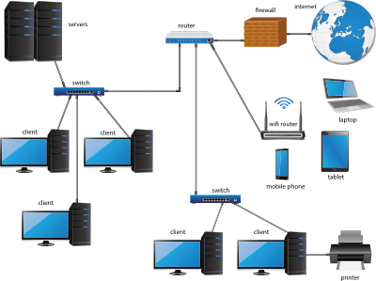
A LAN is the smallest type of network by area. It may still contain hundreds of computers connected by cables and WiFi - as well as other peripherals (e.g. printers), servers and an internet connection through a router.
The internet connection and peripherals are optional.
If you remove the servers you have a peer-to-peer network. If you keep them you have a client-server network.

Typical parts of a LAN
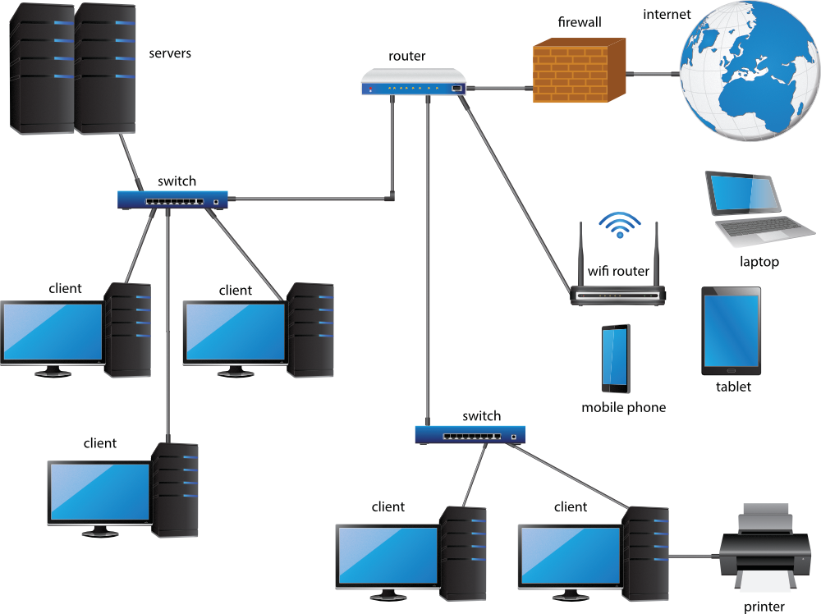
WL is for Wireless Local

Look Ma - no Wires!
A WLAN is the same as a LAN except connection is only by radio (wireless).
This is the type of network most homes have, because laying wires is so messy, ugly and such a schlep and all our devices are wireless anyway and it is so much easier just to plug in the router and not have to do anything else….
Often the same applies to the network in small businesses.
Because of the trend for people to have and use their own mobile devices, almost every network includes a WiFi access point so that workers can BYOD (Bring Your Own Device) instead of working at a fixed desktop supplied by the company.
WLANs are also popular as a way to provide people with internet connectivity in public spaces. These are the so called WiFi 'HotSpots'. That is, areas where there is a WiFi network that you can connect to.
WiFi is (and always has been) slower than the fastest form of cabled network.
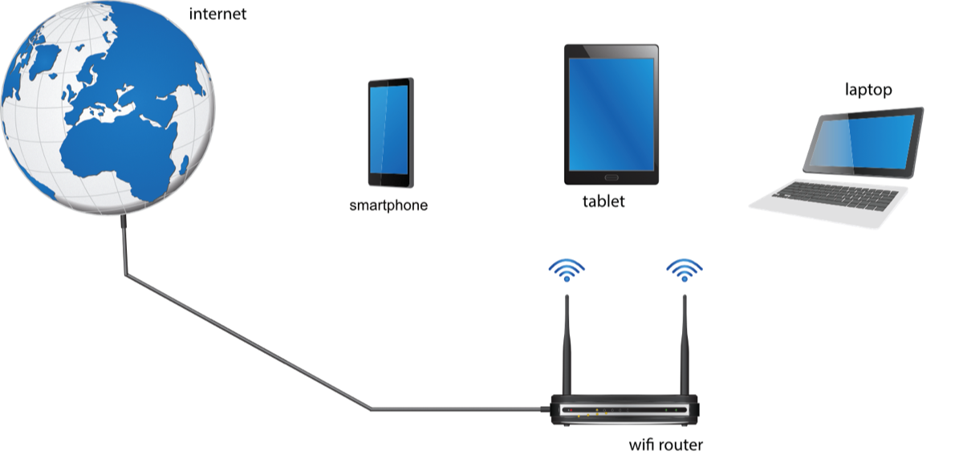
A WLAN uses radio to let devices connect to the network wirelessly.

Typical parts of a WLAN
H is for Home

This network is a LAN or a WLAN - except it is found in your home so it gets its own special name.
Most often this network consists of an internet connection and a Router / WiFi hotspot.
Wiring your house can provide faster, more stable connectivity but takes time and effort and costs money. So most people just stick with the WiFi.
The diagram below shows typical components of a HAN. Some elements are best connected with a cable for better performance and are shown with cables. This does not mean that these devices cannot connect by WiFi.
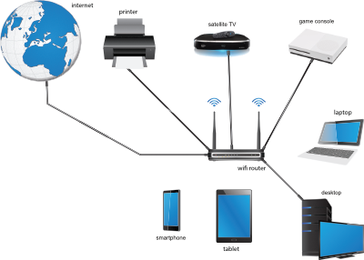
A HAN is a LAN in the home. It is usually WiFi based but some people do create a wired network in their home. The HAN usually includes mobile devices, laptops, desktops, game consoles, Smart TVs, Media Streaming devices, Satellite TV decoders, etc.

Typical parts of a HAN
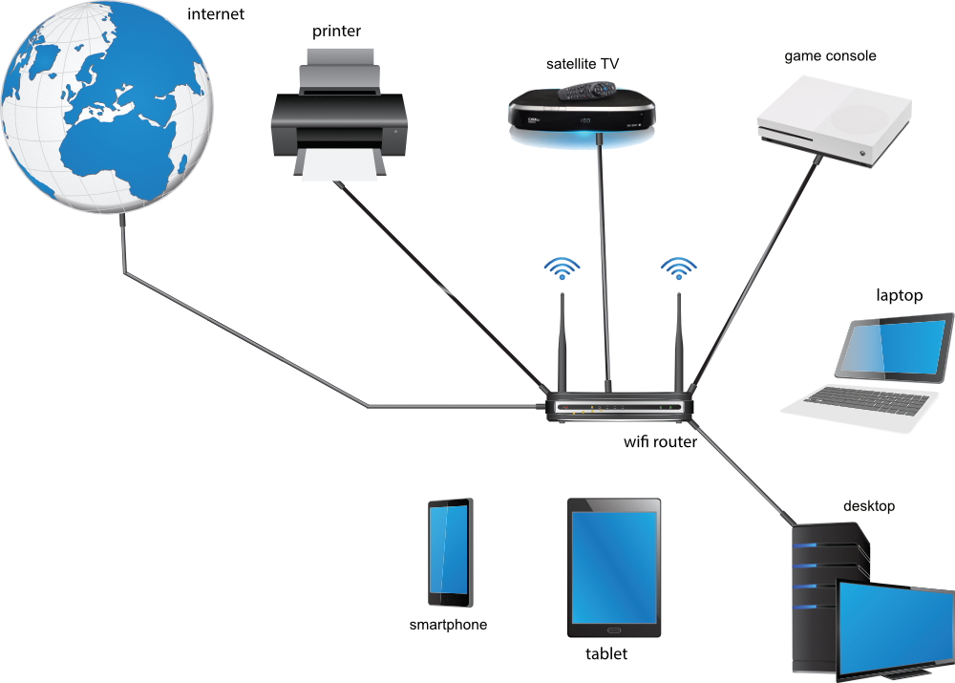
W is for Wide

This network covers a bigger area than a LAN. It is the vaguest of all the ANs, because what it means changes according to context.
If you have a big school with many buildings then you could have a LAN in each building and connect the buildings with a Backbone (of preferably fibre optic cables). Technically your school network now qualifies as a WAN. Some people would call it a CAN (Campus Area Network).
But so does a big city network that connects all the municipal offices around the city (a city wide WAN is called a MAN).
And so does your ISPs network that connects all its customers in the city / country.
Generally a WAN happens when two or more networks are connected together. Preferably over long distances.
Because a WAN is so general and vague people keep on coming up with other ANs to be more specific about the area the network covers (see CAN above).
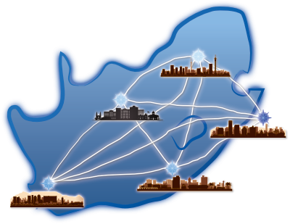
In this WAN networks in cities across South Africa are connected to each other. Parts of a WAN are routers and backbone media. This is typically fibre optic, microwave or satellite.

Diagram of a WAN
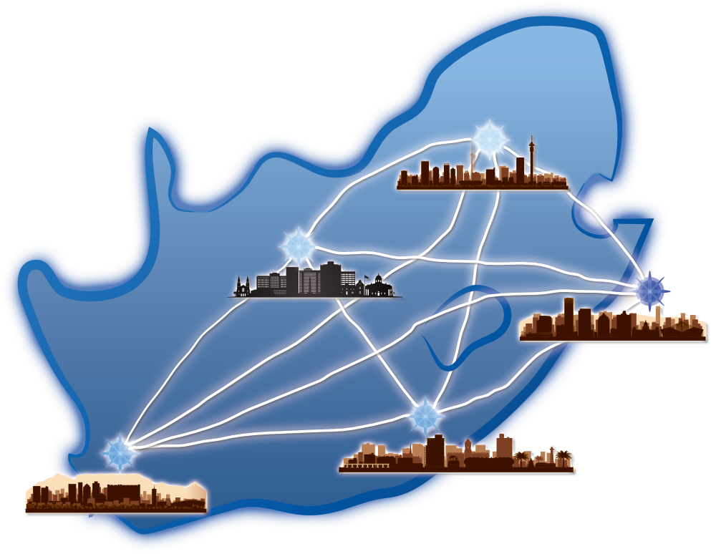


M is for Metropolitan
A fancy way of saying Big City. This network covers a whole city. It is a type of WAN. Just, in a city, you know.

In this MAN networks scattered around Johannesburg are connected together. Parts of a MAN are routers and backbone media. This is typically fibre optic, microwave or satellite. Remember a MAN is a type of WAN.

Diagram of a MAN
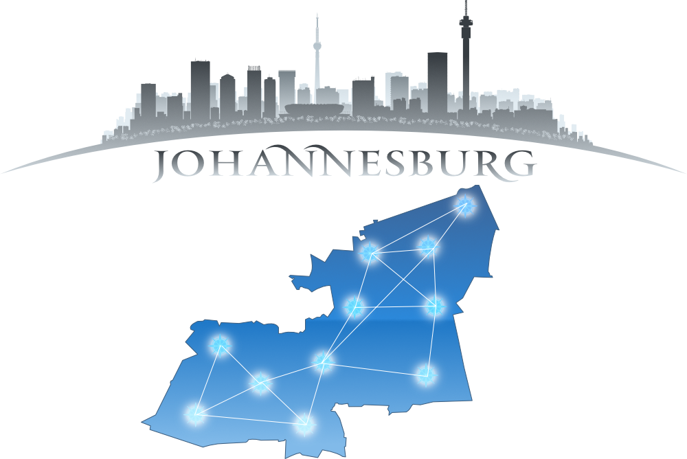


G is for Global
This is where all the ANs are connected together across the world. Another word for this is the Internet.
Of course, if you are a big company or organisation you can create your own GAN (specifically if you are worried about speed, privacy and security). You need a lot of money to do this.
For the rest of us we simply connect our LAN to the internet and then connect our other LAN (say in Australia or Austria or Afghanistan) to the internet as well. The shared GAN that is the internet has connected our networks together.
If we use the internet to create our private GAN then it is best we use VPN (Virtual Private Network) technology to make the connection more private and secure.
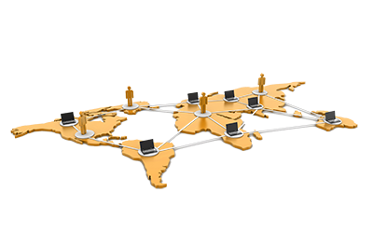
A GAN is a network distributed around the world. The internet is an example of a GAN. It is possible to create a private GAN and this is done by some organisations and Governments.
It is also possible to link networks around the globe over the internet using a technology called VPN (Virtual Private Network) - and this is cheaper than creating a physical GAN.

Diagram of a GAN
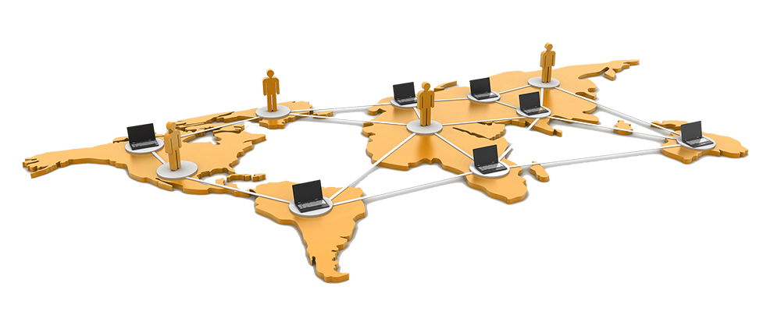

Topologies

Item Title

